**INTEGRATING SOCKET.IO INTO EXPRESS GENERATOR APP**

**REF:**

<http://www.programwitherik.com/getting-started-with-socket-io-node-js-and-express/>

<https://medium.com/@suhas_chitade/express-generator-with-socket-io-80464341e8ba>

FIRST WE NEED TO INSTALL ***socket.io***:

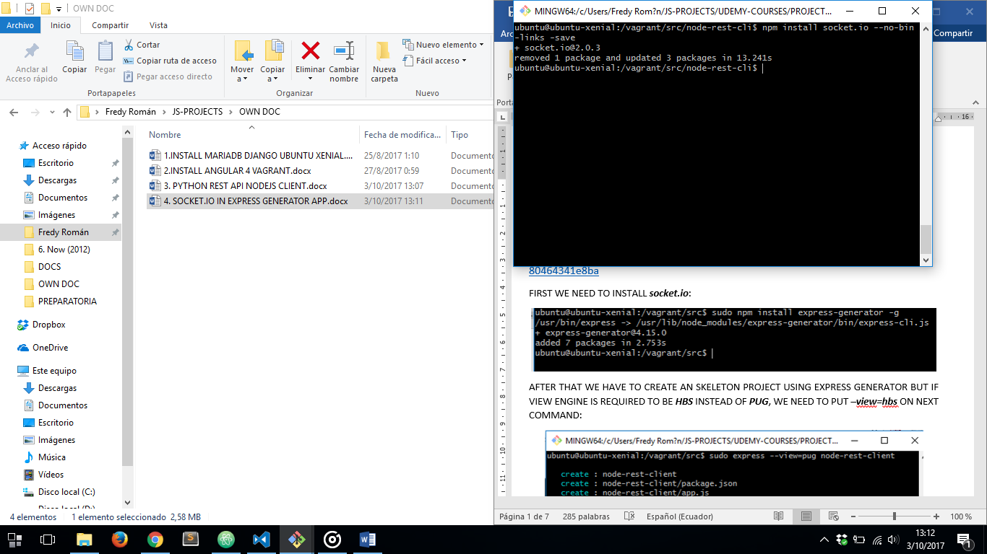

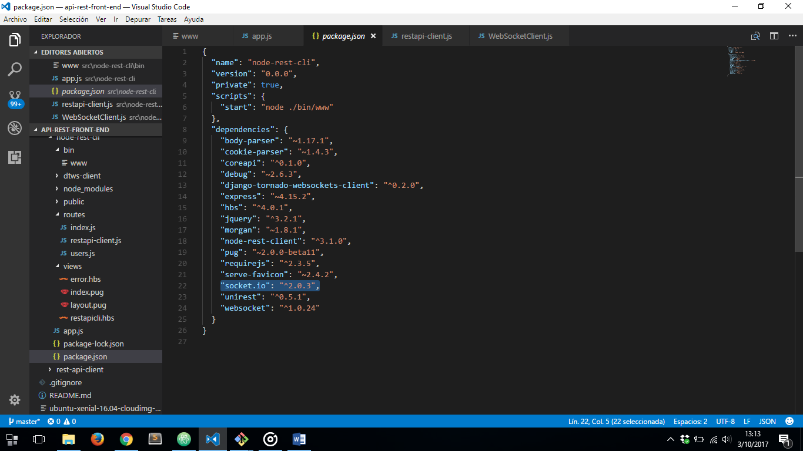

NOW WE HAVE TO MAKE CHANGES TO OUR EXPRESS PROJECT TO MAKE SOCKET.IO WORK FINE:

1. ***app.js*** FILE

DECLARE OUR SERVER AND SOCKET.IO MODULE

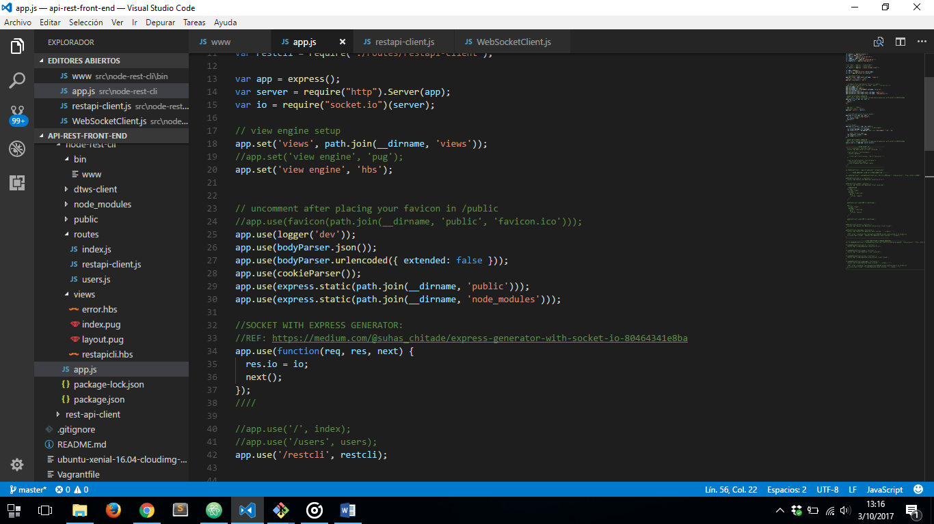

DECLARING WE ARE USING SOCKET:

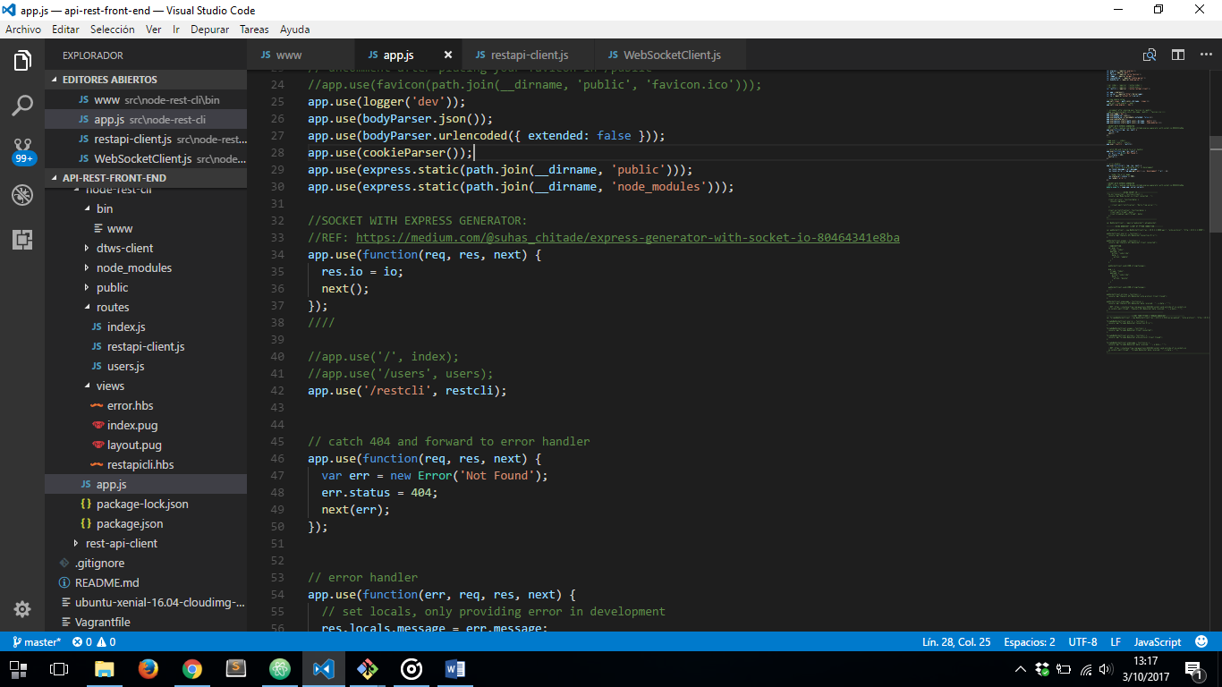

EXPORTS OUR APP AND OUR SERVER WITH SOCKET.IO MODULE INSIDE

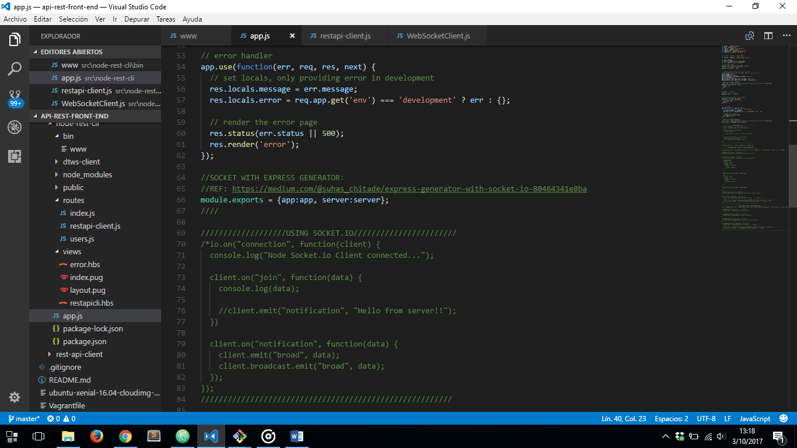

1. ***www*** FILE

REQUIRING APP AND SERVER FROM ***app.js*** FILE

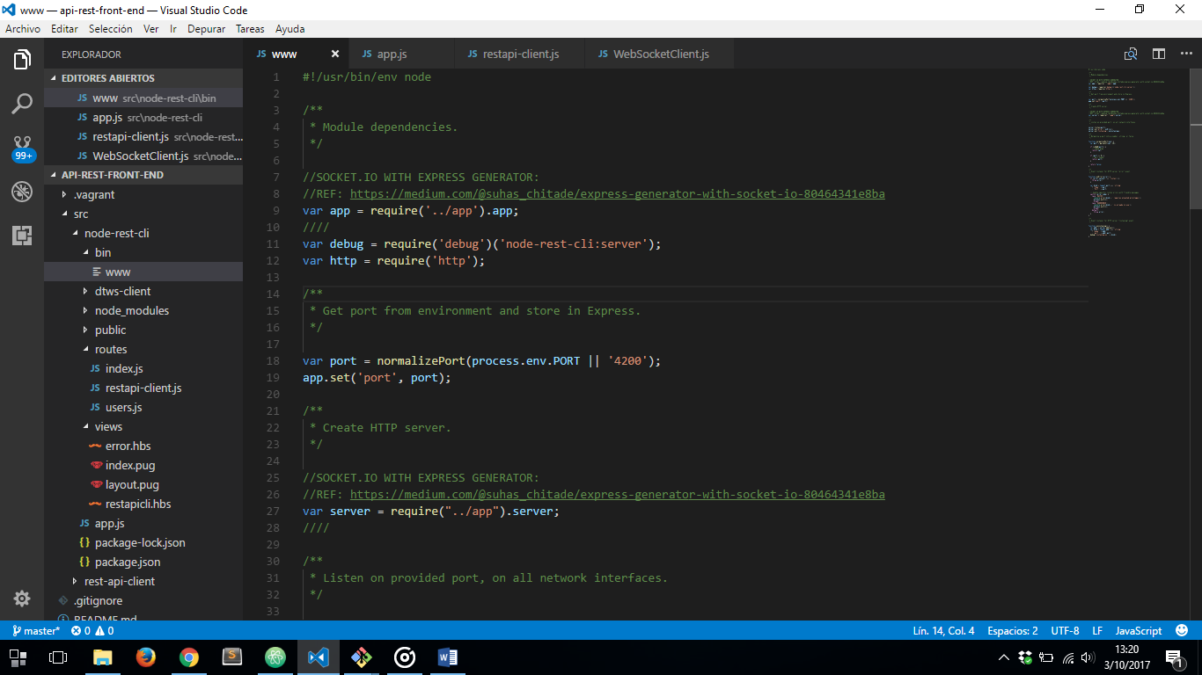

NOW WE ARE ABLE TO USE SOCKET.IO IN OUR EXPRESS GENERATOR APP:

***App.js*** FILE

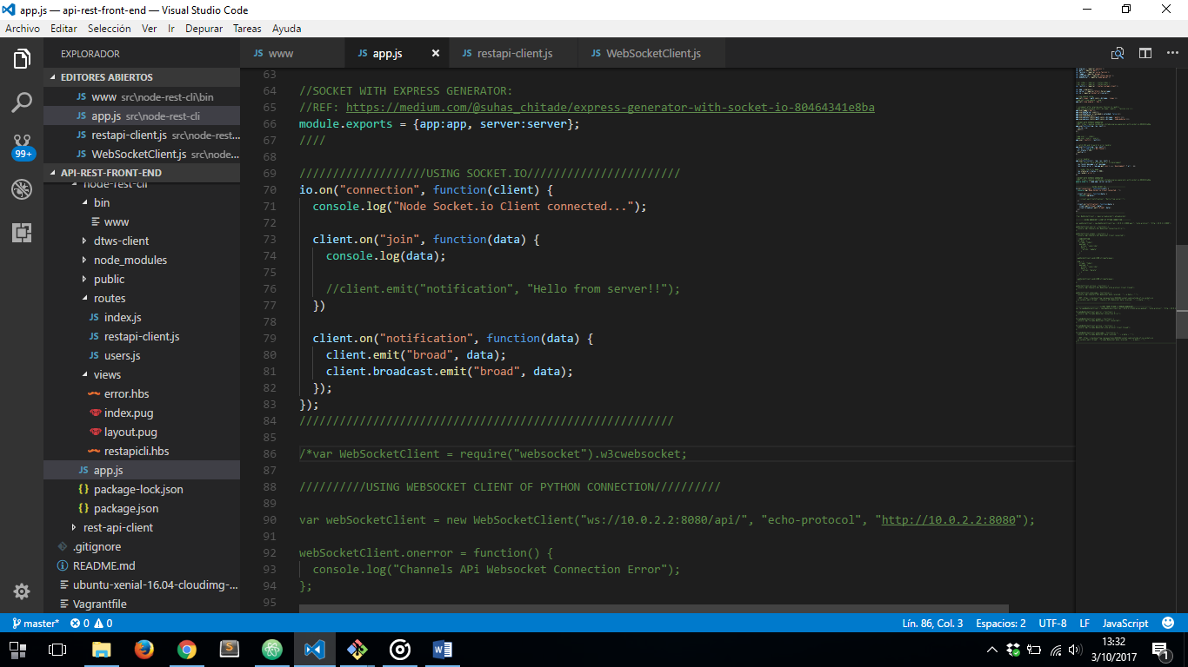

NOW IN THE CLIENT SIDE, TO MAKE DOM MANIPULATING EASIER WE ARE GONNA INSTALL JQUERY USING NPM:

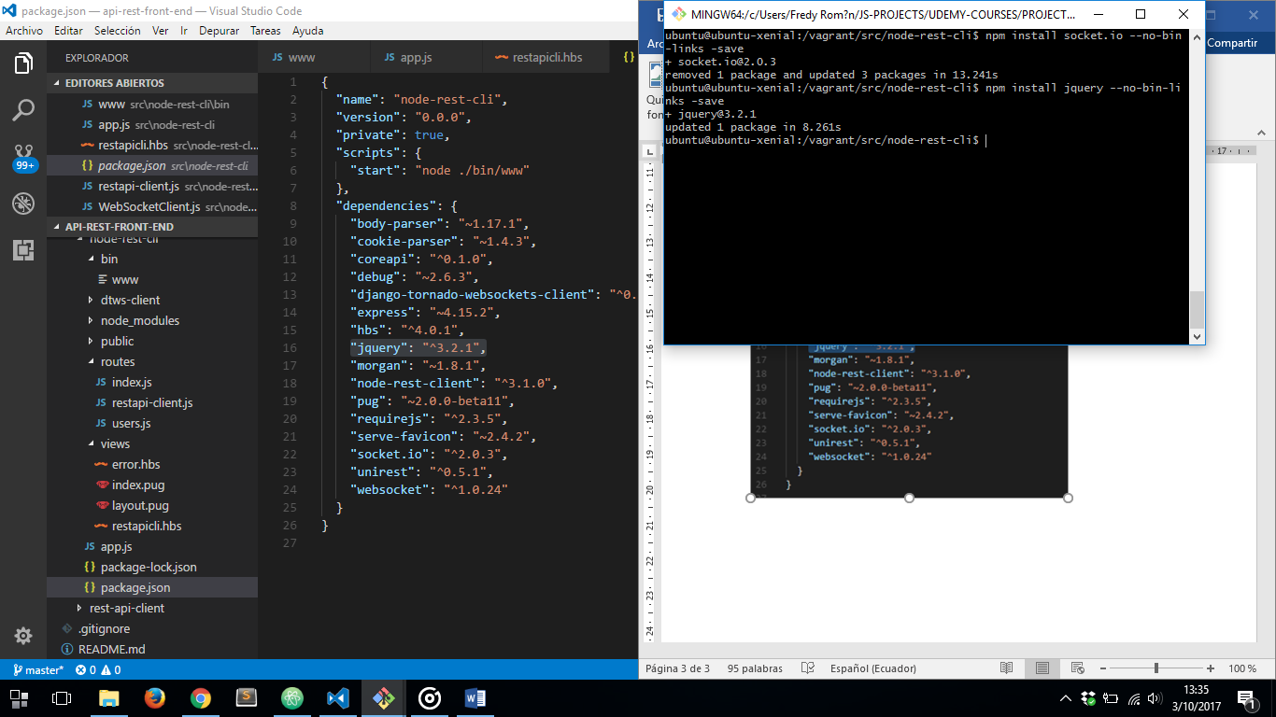

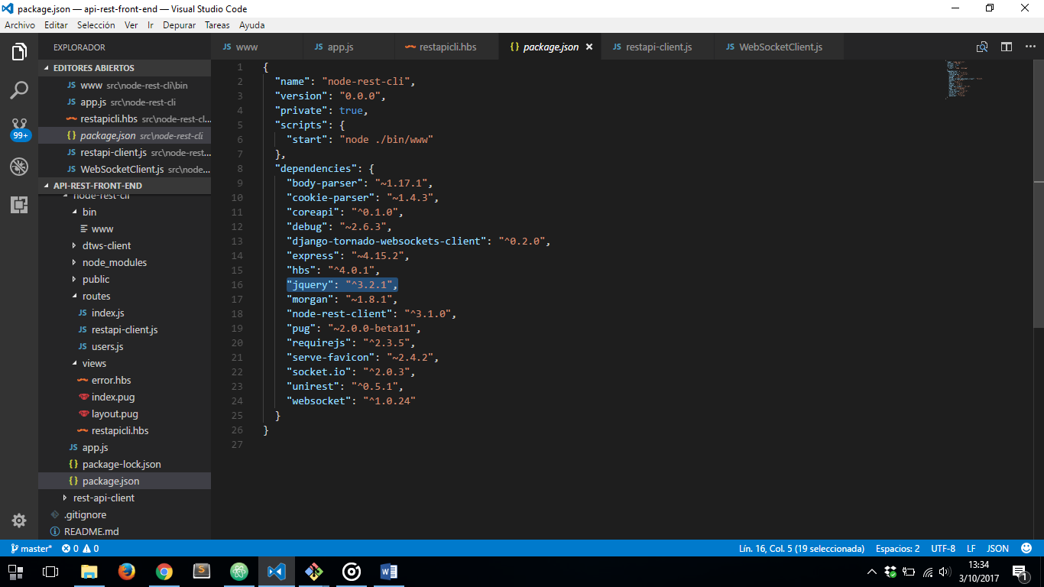

NOW IN OUR ***restapicli.hbs*** WE’VE MADE A SIMPLE CHAT WITH SOCKET.IO

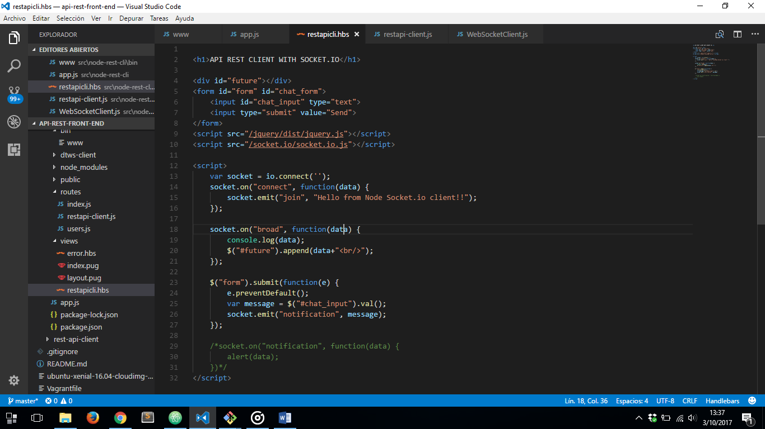

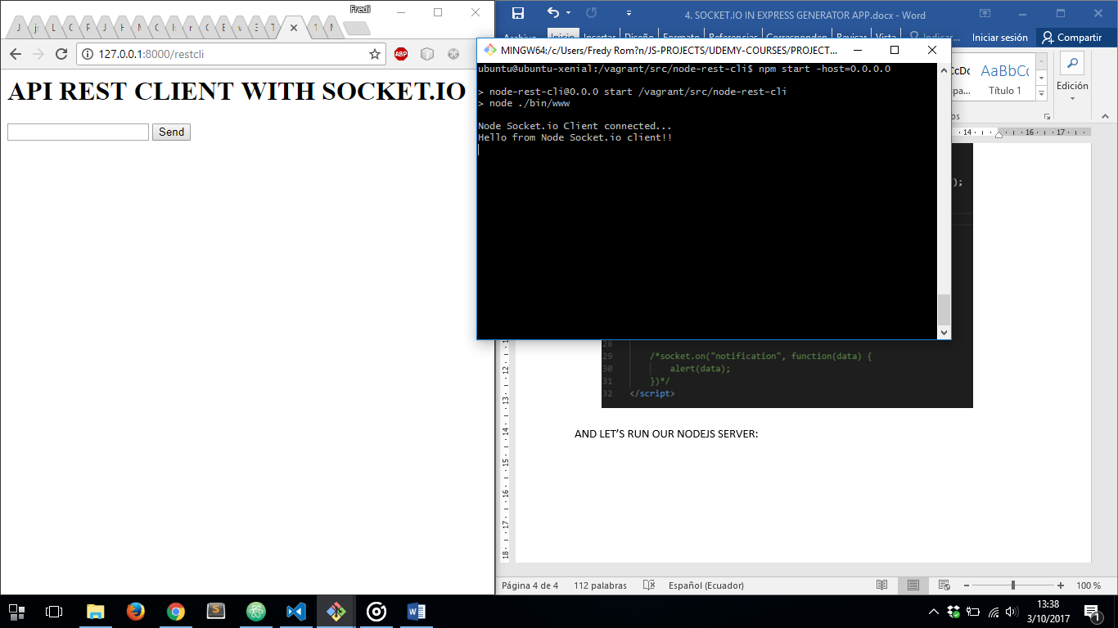AND LET’S RUN OUR NODEJS SERVER: (GOOGLE CHROME CLIENT)

FIRE FOX CLIENT:

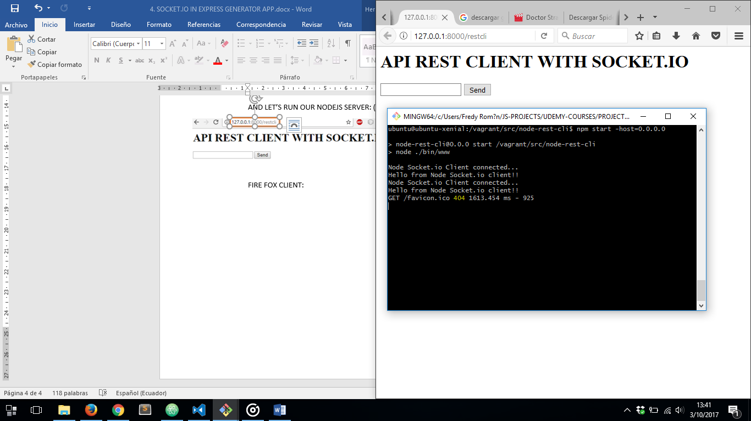

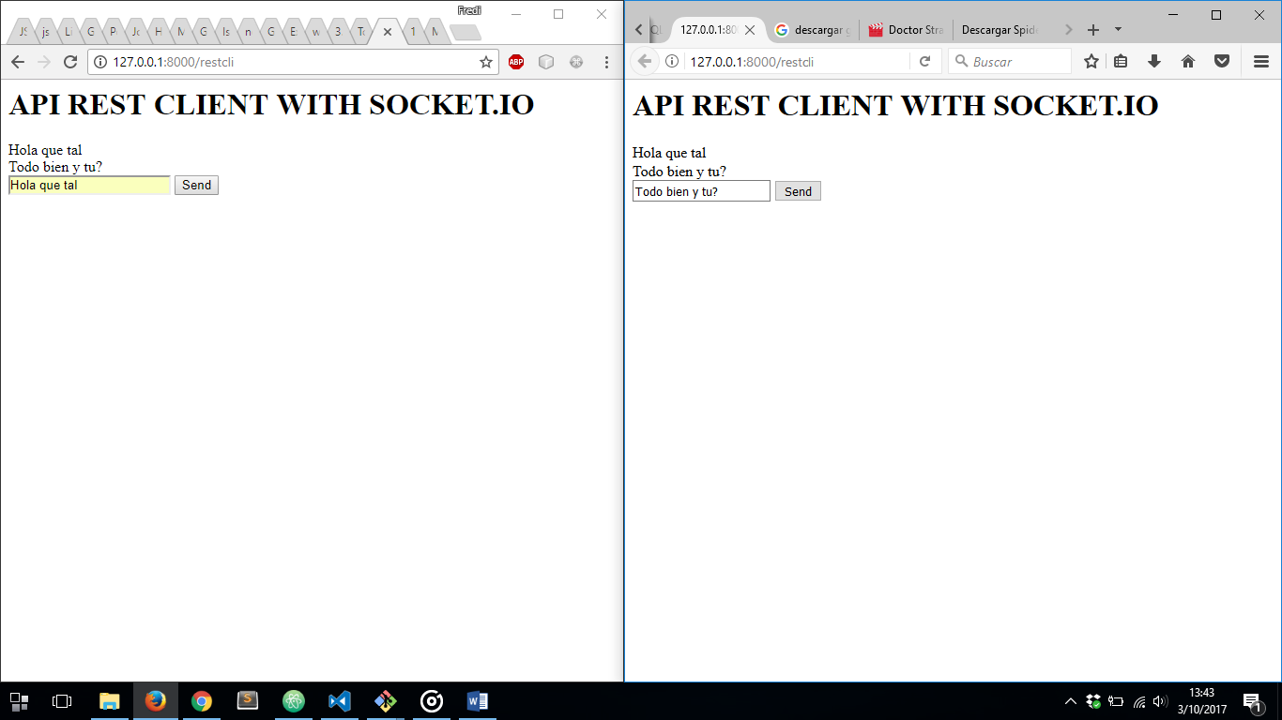NOW LET’S INTERACT WITH BOTH CLIENTS THROUGH A CHAT: